difference of profit payment, profit margin and Accrued profit

Profit payment is the actual amount of money that a company receives as profit. It is calculated by subtracting all expenses, including taxes, from revenue.

Profit margin is a measure of how much profit a company makes relative to its revenue. It is calculated by dividing profit by revenue and multiplying by 100 to express it as a percentage.

Accrued profit is a profit that has been earned but not yet received. It is typically recognized as an asset on the balance sheet.

Here is a table that summarizes the key differences between profit payment, profit margin, and accrued profit:
Characteristic | Profit payment | Profit margin | Accrued profit
Type | Cash flow | Ratio | Asset
Calculation | Revenue - expenses | Profit / revenue * 100 | Profit earned but not yet received
Timing | Actual | Historical | Future
Examples:
- A company sells a product for $100 and has a cost of goods sold of $50. This means that the company's gross profit is $50. If the company also has operating expenses of $20 and taxes of $10, then its net profit is $20. The profit payment for this sale is also $20.
- The profit margin for the company in the example above is 20% (20 / 100 * 100).
- If the company has already sold the product but has not yet received payment from the customer, then the company would have an accrued profit of $20 on the balance sheet.
Importance:
Profit payment, profit margin, and accrued profit are all important financial metrics for businesses. Profit payment is a measure of a company's profitability and cash flow. Profit margin is a measure of a company's efficiency and competitiveness. Accrued profit is a measure of a company's future earnings potential.
Investors and analysts use these metrics to evaluate a company's financial performance and to make investment decisions.

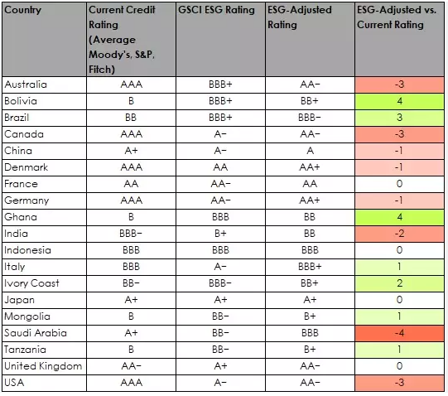 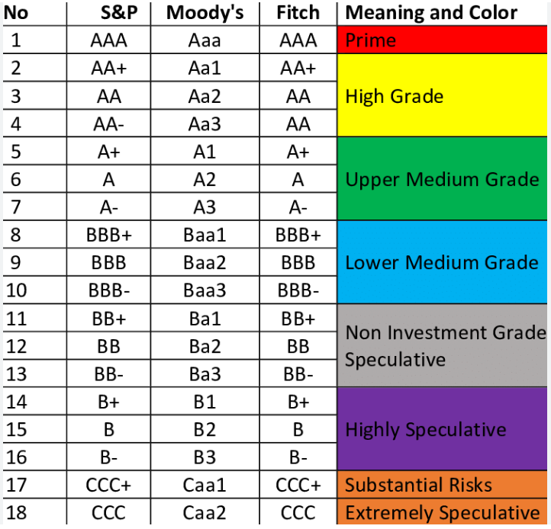 sovereign credit rating by country

